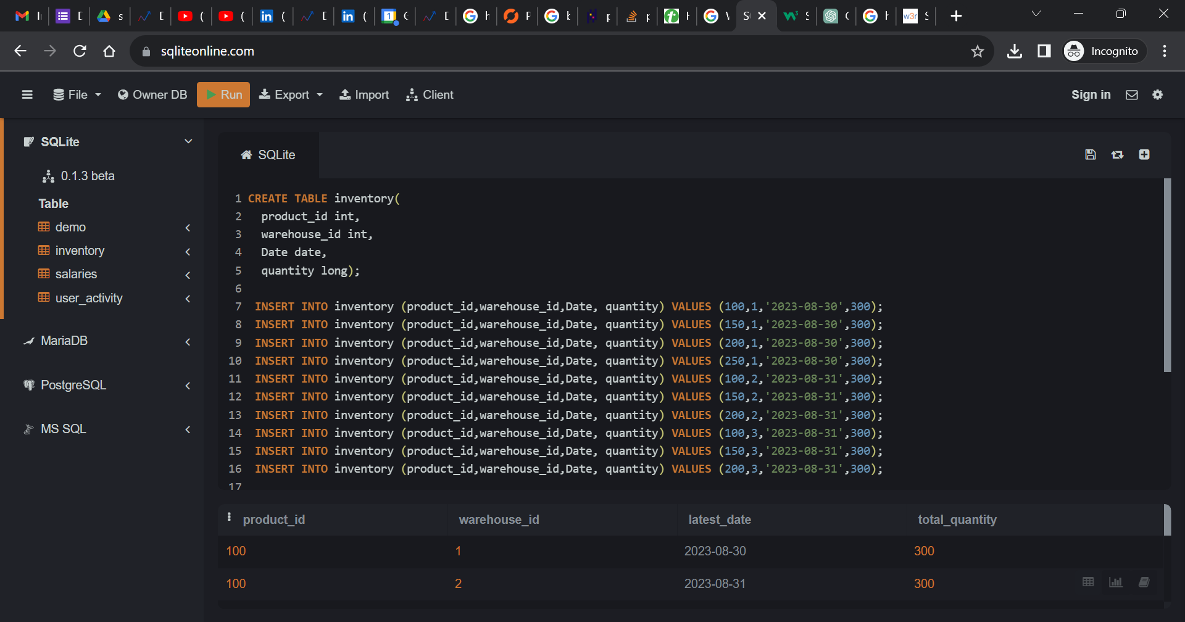

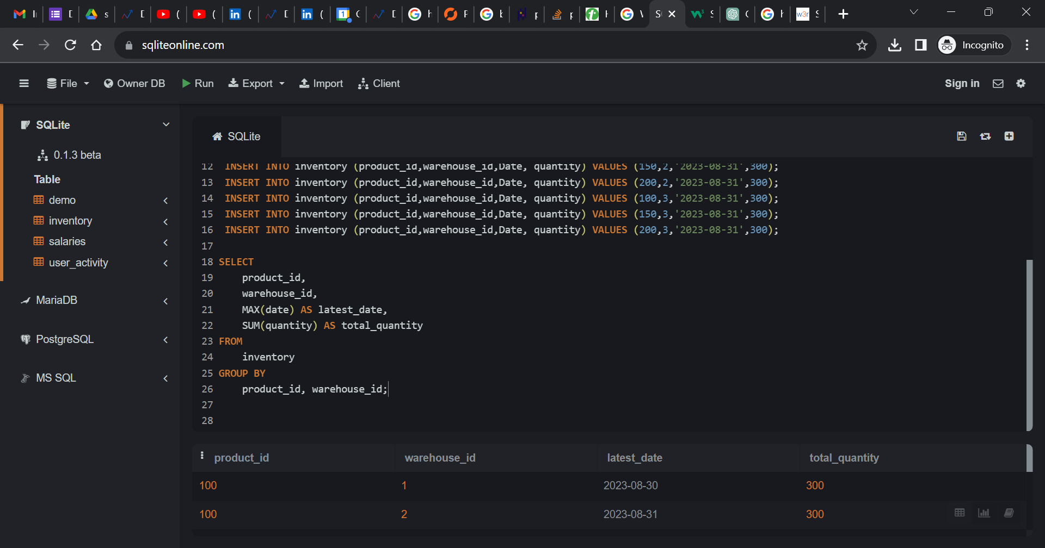

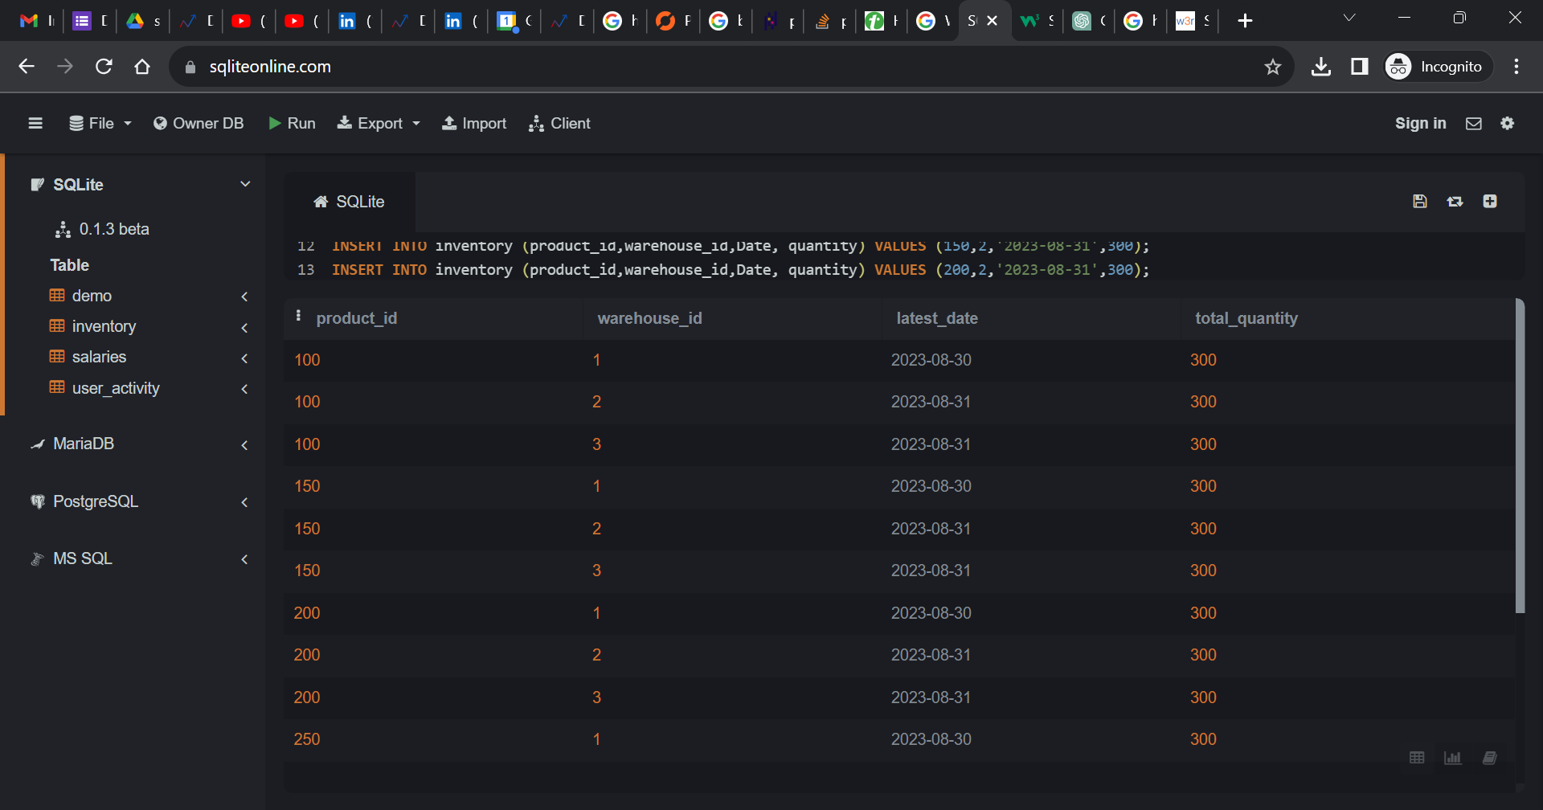

create table inventory(

product_id int,

warehouse_id int,

Date date,

quantity long);

insert into inventory (product_id,warehouse_id,Date, quantity) values (100,1,'2023-08-30',300);

insert into inventory (product_id,warehouse_id,Date, quantity) values (150,1,'2023-08-30',300);

insert into inventory (product_id,warehouse_id,Date, quantity) values (200,1,'2023-08-30',300);

insert into inventory (product_id,warehouse_id,Date, quantity) values (250,1,'2023-08-30',300);

insert into inventory (product_id,warehouse_id,Date, quantity) values (100,2,'2023-08-31',300);

insert into inventory (product_id,warehouse_id,Date, quantity) values (150,2,'2023-08-31',300);

insert into inventory (product_id,warehouse_id,Date, quantity) values (200,2,'2023-08-31',300);

insert into inventory (product_id,warehouse_id,Date, quantity) values (100,3,'2023-08-31',300);

insert into inventory (product_id,warehouse_id,Date, quantity) values (150,3,'2023-08-31',300);

insert into inventory (product_id,warehouse_id,Date, quantity) values (200,3,'2023-08-31',300);

SELECT

product_id,

warehouse_id,

MAX(date) AS latest_date,

SUM(quantity) AS total_quantity

FROM

inventory

GROUP BY

product_id, warehouse_id;